1. This is a report of an analysis of Lonely Planet’s marketing channel conflicts and cannibalization issues.

Marketing channel conflicts

* The published **Travel Guides** generate the most revenue and are needed for the company to stay operational. But the **online travel information** conflicts with the Travel Guides because their information is generally more current and accurate.
* The conflict hurts the business of each other by drawing away potential revenue from the same customers.

Cannibalization issues

* The online travel information cannibalizes the sales market of the Travel Guides because the information is generally more current and accurate than the published Travel Guides.
* Just because it is better does not indicate that the Travel Guides don’t serve a purpose. But if they are perceived to be better, then they have intrinsic value and should be sold to acquire. And the Travel Guides serve the additional purpose of providing the (lesser) comparison needed to warrant the price of the online travel information.

2. Here is a list of new products that would take advantage of the Internet technologies:

* More detailed, online travel information, provided through a paid subscription.
* Make a mobile version of the online travel guides, as a convenience to the traveler. This would be an option in the paid subscription.
* Internet, downloaded Travel Guides, provided through a paid subscription.
* Make a mobile version of the Travel Guides, as informative reading to relax the traveler. This would be an option in the paid subscription.
* Publish the printed Travel Guides in its own magazine, for example, the Travel + Leisure Magazine[1] and the Condé Nest Traveler[2]. The websites of these magazine companies are examples of successful ideas.
* Make free offers for new subscriptions that return the most revenue.

3. A solution to provide smaller, more specific information to customers can be a newsletter and a subscribed e-mailing list. The newsletter can be free and sent to customers by email. Each emailed newsletter would have articles from the travel guides that the customers can choose and digest as they need. The email would conveniently be on their smart phone. Some advanced articles could charge a small additional cost, i.e. $1.99 to download, on the spot; one example.[3]

1. A Google search of the Travel + Leisure Magazine top result is an advertisement link to subscribe to their magazine < <https://subscription.foodandwine.com/storefront/subscribe-to-food-and-wine/site/wi-3term-0714.html?pkw=bing_sem&link=1022988&fpa_oc=WI+Bing+SEM> > and when you subscribe to “Food & Wine” just

   “Select your term below for just $1 an issue — **you save 83%!*”** Their official website < <https://subscription.foodandwine.com/storefront/subscribe-to-food-and-wine/site/wi-3term-0714.html?pkw=bing_sem&link=1022988&fpa_oc=WI+Bing+SEM> > has simple, but interesting buttons to click on, as shown below:

   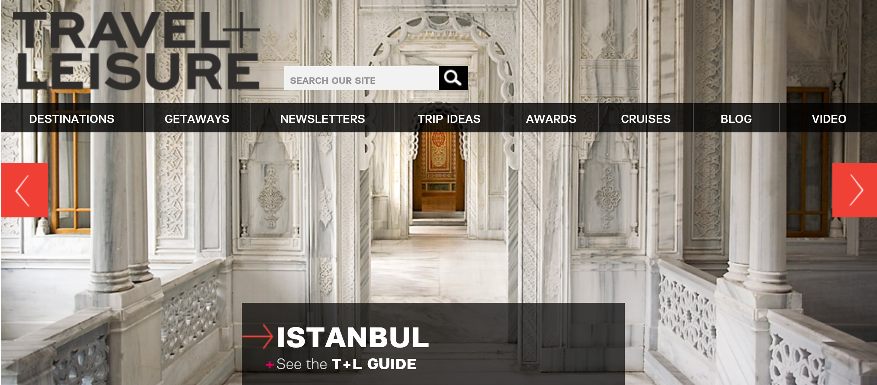
2. A Google search of the Condé Nest Traveler Magazine top result is an advertisement link to subscribe to their magazine < <https://subscribe.cntraveler.com/subscribe/cntraveler/90891?source=msn_sem> > and get 6 issues for only $6 and a free travel bag! Their official website < <http://www.cntraveler.com/> > is very compelling and the dynamic impact on your interest level is affected by what they show on the entire computer screen (window). It is an interesting picture of a red-colored canyon and just the question,

   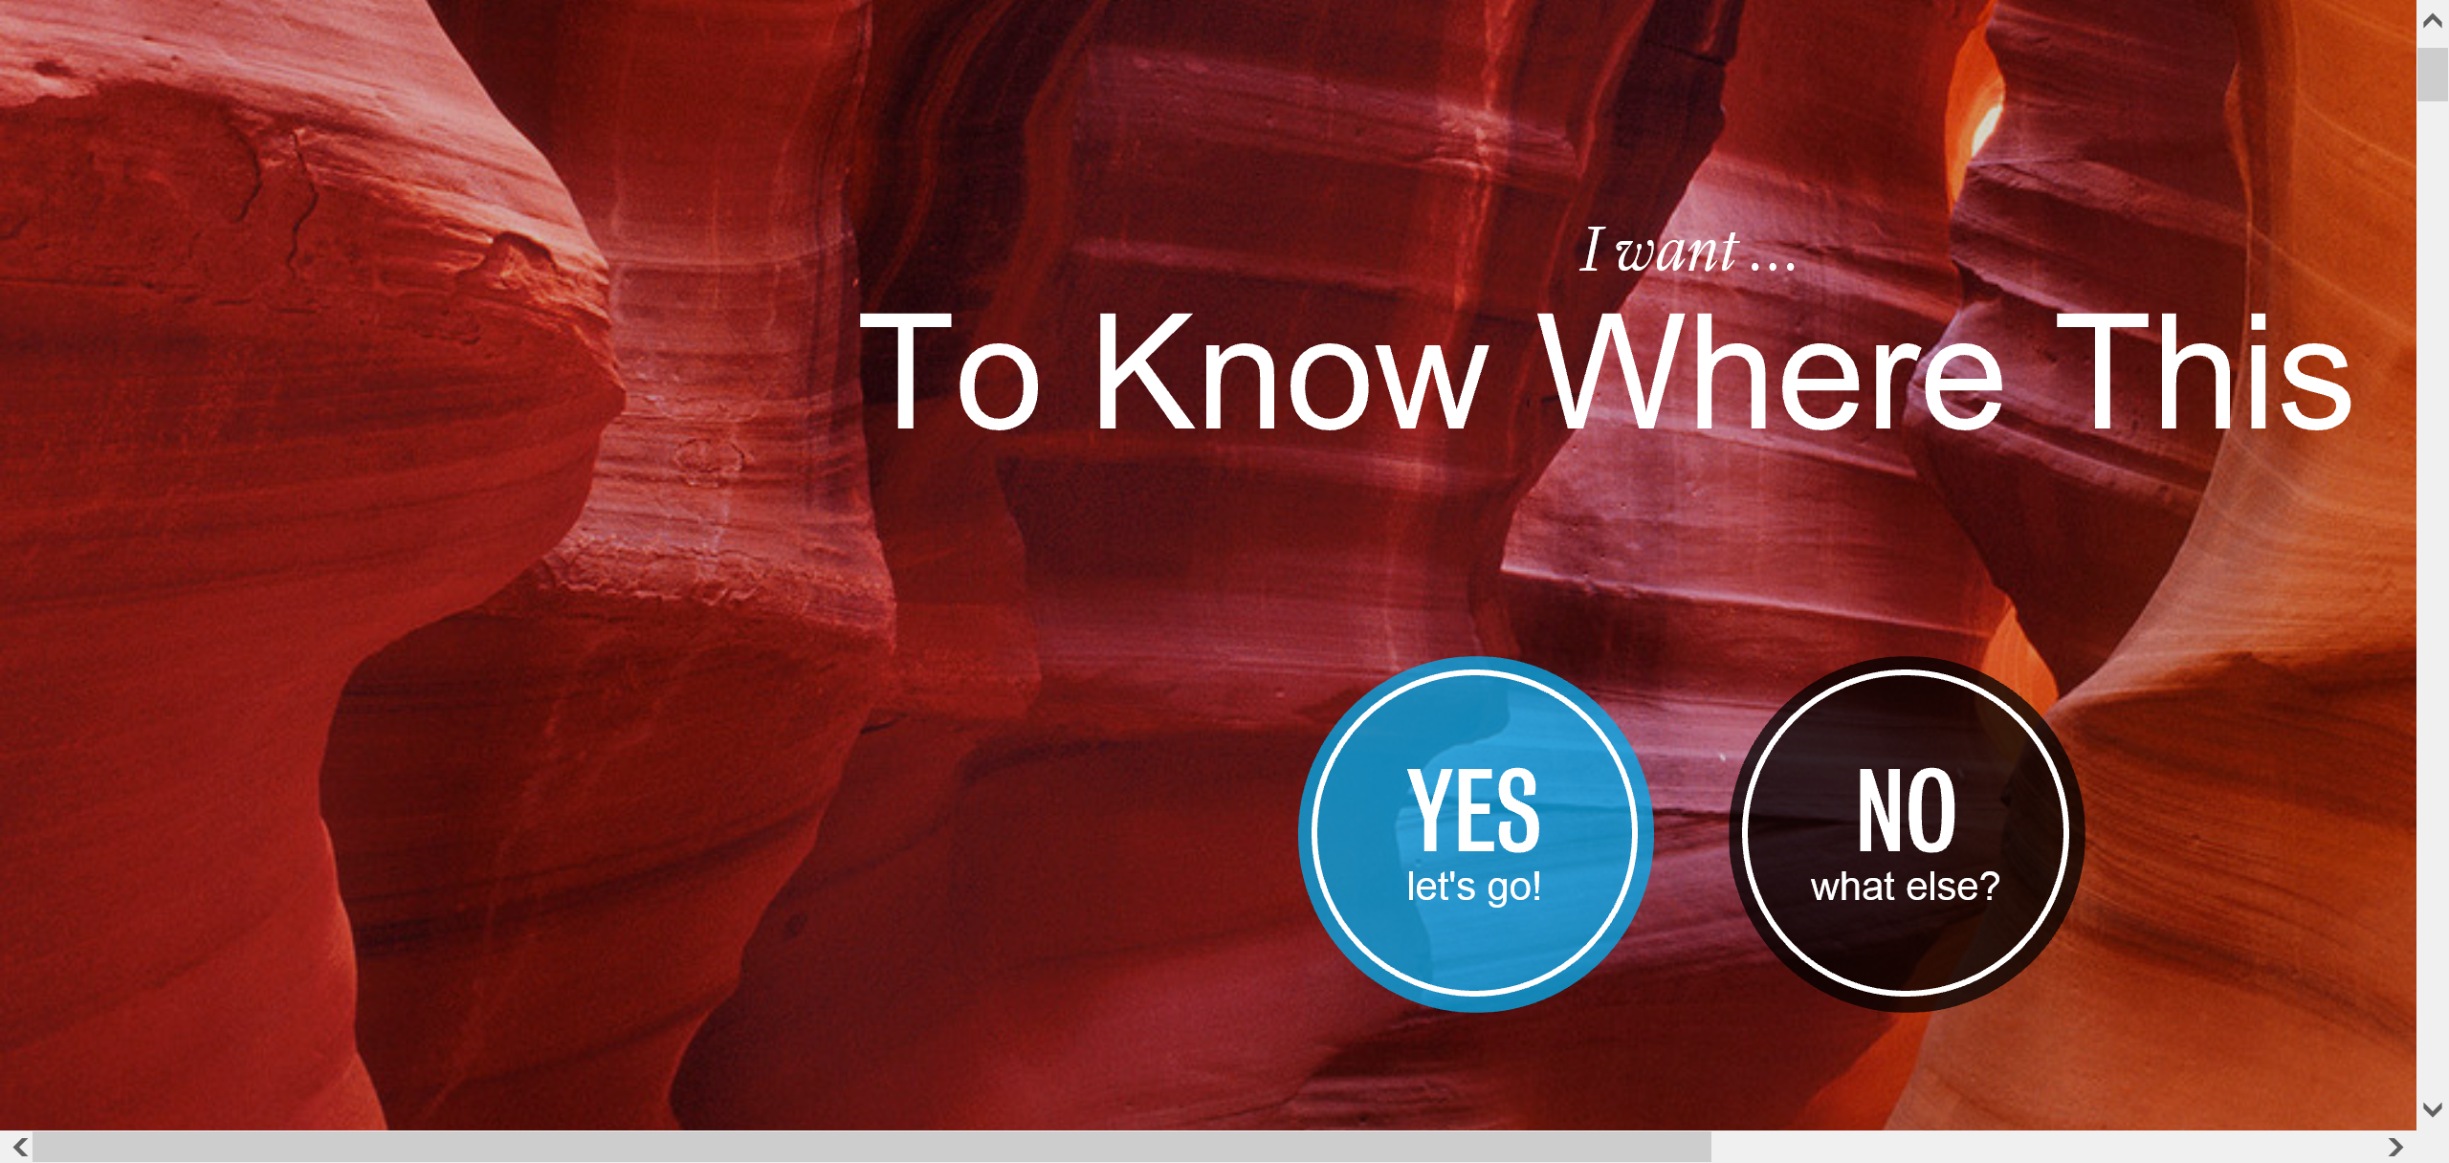
3. Example: “Dunhill Travel Deals Newsletters,” at < <http://www.dunhilltraveldeals.com/travel-newsletter/> >.

   